Bead 0.5 User Guide

Table of Contents

What’s new in v0.5 2

A Complete Workflow 3

Start the GUI 3

Start Matlab parallel pool 3

Select images 4

Parameter settings: Image 5

Parameter settings: Detection 5

Parameter settings: General 6

Bead detection 6

Select control beads 7

Bead fitting and selection 7

Save and load sessions 10

Output files description 11

Release notes 12

Version 0.5 12

Version 0.42 12

Version 0.41 12

Version 0.4 12

Version 0.3 12

Version 0.23 12

# What’s new in v0.5

1. New user interface
2. Support one or two images and one or two channels (experimental)
3. Select which channel is background and which is signal (experimental)
4. Support linear fitting (experimental)

# A Complete Workflow

## Start the GUI

Double click beadGUI.m to start Matla.

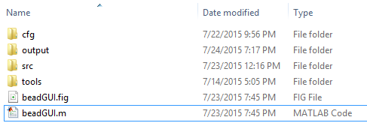

Run that file, a GUI will be shown

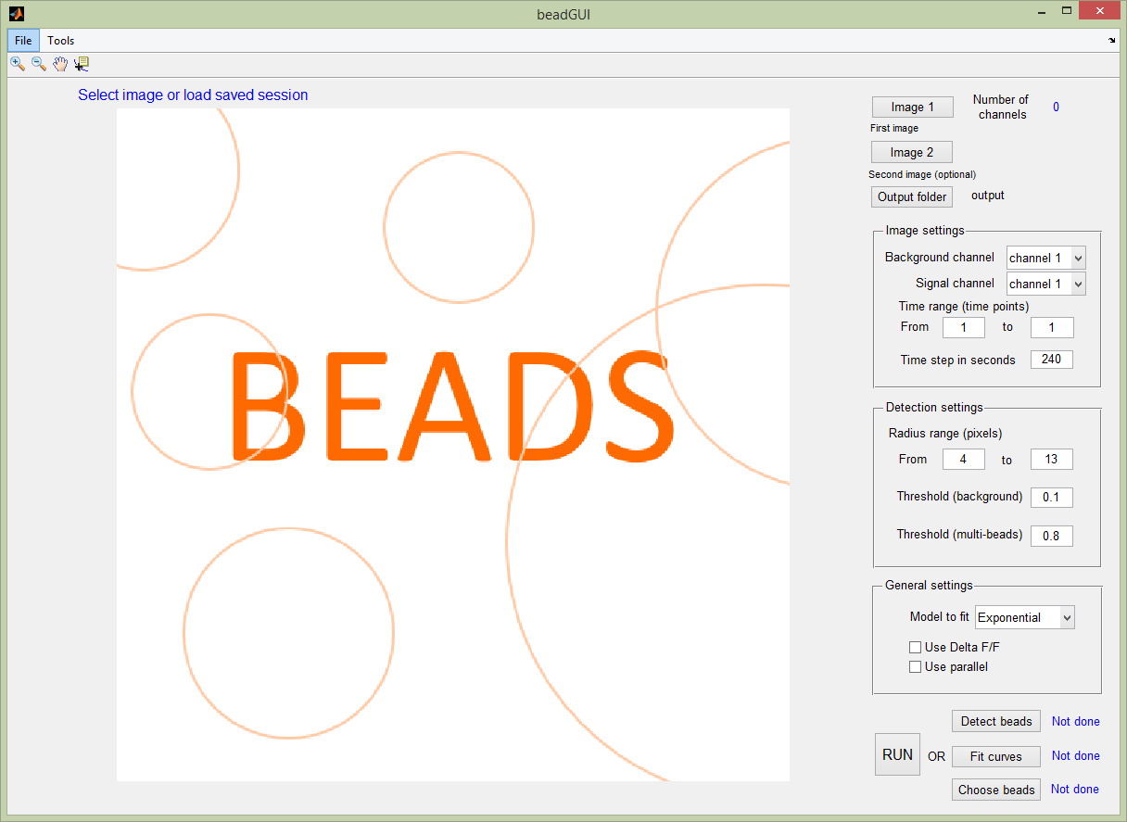

## Start Matlab parallel pool

If possible, start the parallel pool, this will greatly accelerate the program. For newer versions of Matlab, click the menu item Tools – Start parallel pool.

Or equivalently, click the bottom left part of Matlab to start it.

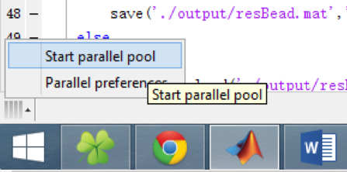

Prior versions of Matlab may require different command to start the parallel pool, for example:

>> matlabpool open

## Select images

Click button ‘Image1’ to select the image in the prompted dialogue. Both LSM and TIFF files are acceptable. If you have second image, click button ‘Image 2’ and choose the image. The selected file names and the first channel of first time point will be shown. The images are read into the program in this step, so it may take some time (usually less than one minute).

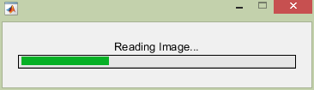

If TIFF image is chosen, you will be prompted to input the number of channels.

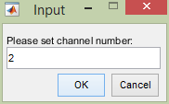

You can also select ‘Output folder button’ to choose the output path. Otherwise the default folder is used, which is ‘./output’. The results of this step looks like

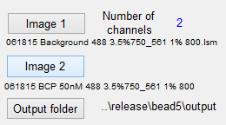

## Parameter settings: Image

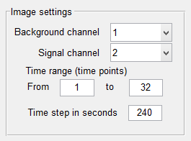

You need to specify which channel is used to detect beads (background channel) and which channel is used to extract signal curves for fitting (signal channel).

**After** the image is selected, the number of time points is shown. User can choose the desired time range. For TIFF files, users need to set the time duration between two consecutive time points. For LSM file, this information is read from the image file automatically.

## Parameter settings: Detection

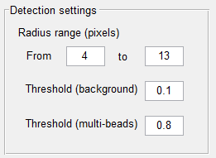

Set the radius range of beads (in pixels). Using an inadequate range may decrease the performance and need more time to compute.

There are two thresholds to control the speed of the algorithm. Threshold (background) is used to separate the image (scaled to [0, 1]) to background and foreground, and the centers of the beads are assumed to be within the foreground. The foreground is then split into many clusters of beads for detection. The smaller each cluster is, the faster the code. So a higher threshold like 0.15 might be suitable for some very dense images. But higher threshold may result in lower detection quality (more missing or shift) for darker beads. This threshold is image dependent, but it is recommended to choose a relatively lower value unless it is too slow. **Usually 0.1 is a good choice**.

The threshold (multi-beads) determines the number of beads to detect in each iteration (ntry). Here 0.8 means any beads with the score larger than 80% of the score for the best bead is selected in this iteration. So a smaller value can accelerate the code. If it is set to 1, only one bead is detected in each iteration, which is used for previous versions and is the slowest. This threshold should has less impact on the quality. But if it is too small, the quality might be affected. **Values around 0.8 should work well for most cases**. Set to 1 for better performance, and much slower.

## Parameter settings: General

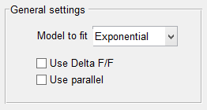

To use parallel, check this box. If some problems happens for parallel, uncheck it. To use $ΔF/F$, check the option; otherwise $ΔF$ will be used. You can also choose to fit the model using exponential or linear models.

## Bead detection

Click ‘Detect beads’ to continue. The program will first detect the beads. This step may take from 10 minutes (computer with 12 cores) to more than two hours (single core).

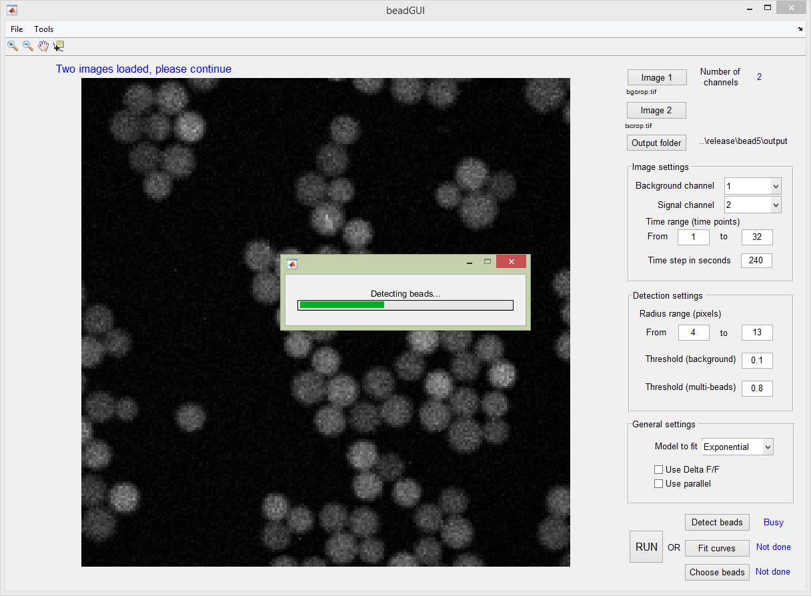

## Select control beads

After beads are detected, you will be asked to select control beads. If there is no control beads, you can simply click continue on the bottom left. You can click  to zoom in, zoom out or move in the image. To select control beads, make sure **NONE** of the three is selected. If they are selected, like , click it again to de-select it. For example, we zoom in to this part:

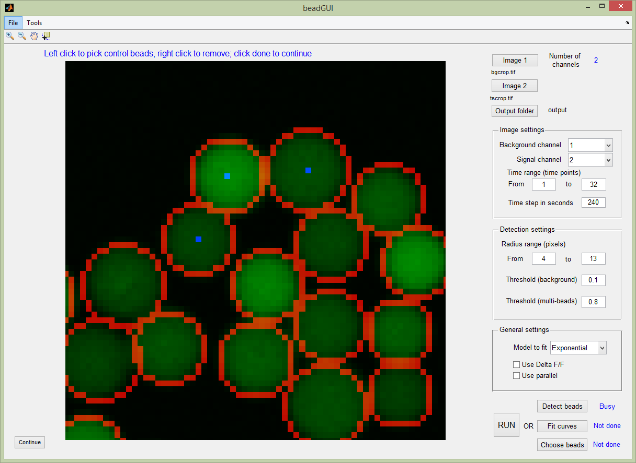

Click anywhere within the control bead, a blue dot will be shown inside it. Click at another place to select another one. The coordinates will also be shown in the command line. You can use  to move to other part of the image to continue selection. Remember to deselect  before choose control beads. To remove a control bead, **right click the blue dot** (still with  deselected). The blue dot will disappear. And the command line will display ‘Remove X,Y = …’

After selecting all control beads, close continue at the bottom left part and the results will be saved. Image alignment and curve extraction is then performed.

## Bead fitting and selection

Click ‘Fit the curve’ to fit each curve against the exponential curve or a line.

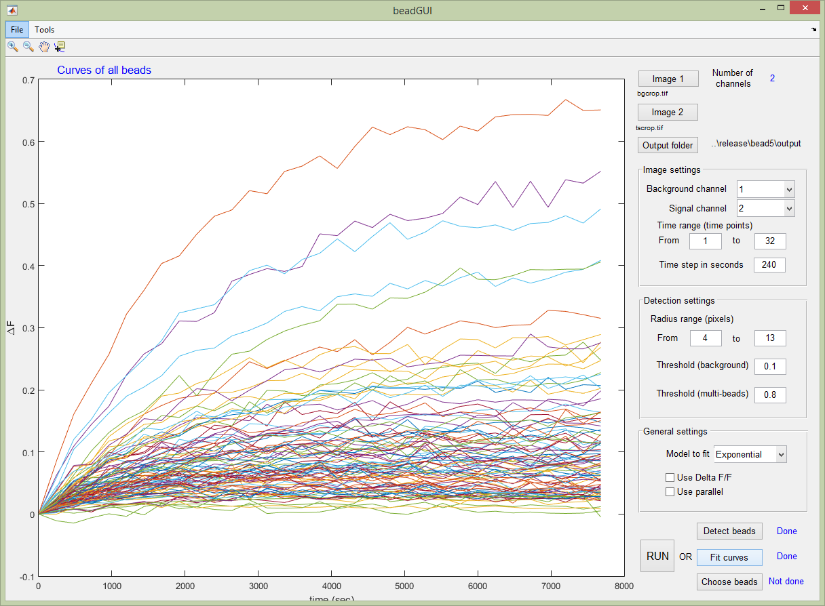

Then click ‘Choose best beads’, users are asked to zoom in the scatter plot of $τ$ and $ΔF$ to the region of interest. Then click continue.

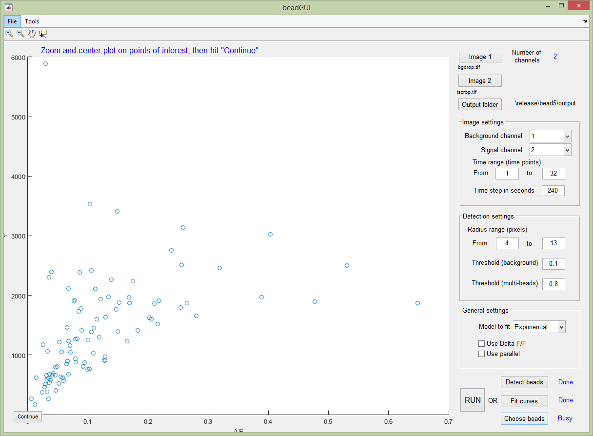

Users can select the good beads. Type in 0 to continue, or 1 to select again.

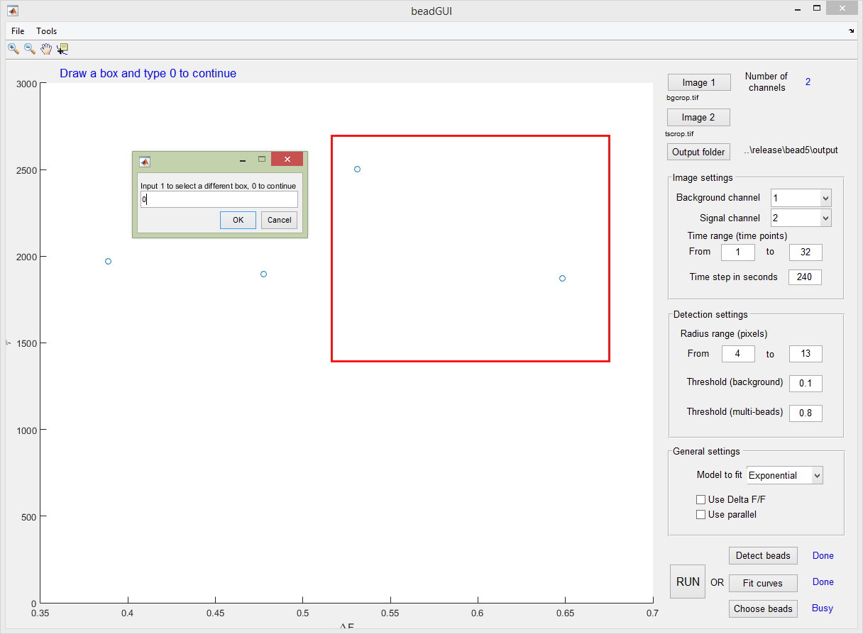

Curves for the selected beads will be saved in the background, along with all the relevant figures and movies (saved in the output folder you specified in parameter setting). When everything is done, you will see this.

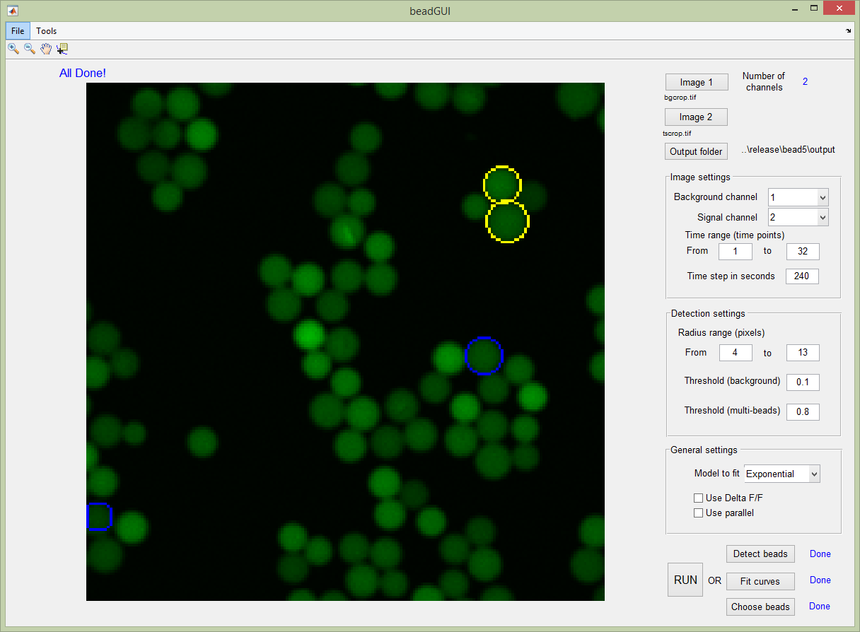

Users can also click ‘Run all’ to do all the above things.

## Save and load sessions

Users can save the session at any time. For example, when beads are detected, the results can be saved by File – Save session. The extension for session files is .seesion.mat, which is automatically attached. This could take up to several minutes.

The saved session can be loaded by File – Load session. This should finished in 20 seconds.

All the data will be loaded and file path will be set.

During the process of saving and loading sessions, a dialog will be shown.

# Output files description

All the images and files are saved in the output folder.

|  |  |
| --- | --- |
| File name | Description |
| res_bead.tif | All detected beads circled in red |
| res_bead_highlight.tif | All detected beads circled in red, the finally selected ones are circled in blue |
| res_bead_highlight_control.tif | All detected beads circled in red, the finally selected ones are circled in blue, and the control beads are in yellow. |
| extracted.tif | The pixels in red are used to extract curve from channel 2. The average of channel 2 in time lapse is shown in blue. |
| bead_selected.tif | Selected beads circled in blue with blue text label on background channel. The control beads are in bright yellow, also with text label in yellow. |
| bead_selected_signal_channel.tif | Selected beads circled in red on signal channel (time lapse) |
| bead_n_selected_signal_channel.tif | Selected beads circled in red on signal channel (time lapse), each beads is cropped so that only those near it is shown |
| all_beads_curves.tif | Curves for all beads |
| bad_beads_curves.tif | Curves for bad beads, if any exists |
| bead_n_curves.tif (the same number as the beads selected) | Curves for finally selected beads, ‘n’ in the file name is the bead ID |
| bead_control_n_curves.tif (the same number as the beads selected) | Curves for control beads, ‘n’ in the file name is the bead ID |
| beads_dff_tau_scatter.tif | The scatter plot of $ΔF$ (or $ΔF/F$) versus $τ$ |
| beadsInfo.xlsx | Information for finally selected beads, control beads, as well as the mean of the whole signal channel in Excel format. Including bead ID, position (row and column), $ΔF$ (or $ΔF/F$) and $τ$. It also include a summary of bead number. |

# Release notes

## Version 0.5

1. New user interface
2. Support one or two images
3. Support one or two channels
4. Select which channel is background and which is signal
5. Support linear fitting
6. Limit the range of $τ$ and ‘a’ in curve fitting

## Version 0.42

1. Option to choose radius range (in pixels)
2. For each bead center, choose a circle with highest mean value in channel 2. Extract curve based on pixels in this curves as well as one circle outside it and one circle inside it.
3. Bug fix: index for the control beads labelled in the output

## Version 0.41

1. Bug fix: using unaligned background as F0

## Version 0.4

1. Select control beads after detection
2. Report curves, $ΔF$ and $τ$ for control beads
3. Save to Excel support platforms other than Windows
4. Include summary information in the Excel file
5. More output figure types
6. Bug fixes; Now tested on Matlab 2010b for better compatibility

## Version 0.3

1. Mean deltaF from entire image (blue channel)
2. DeltaF and tau of the selected beads (blue channel)
3. Coordinates of location for selected beads
4. Time-lapse (in the blue channel) with the selected beads circled
5. Set Delta F/F or simply Delta F

## Version 0.23

1. Support LSM and TIFF
2. Can choose time range in the GUI
3. Algorithms updated to allow threshold setting for faster bead detection
4. Set thresholds to accelerate the program for very dense image
5. All the images are saved to the output folder as tiff format